Rotary Club of Kathmandu Mid-Town
Breakfast Chatter




7 October 2011 The Weekly Bulletin of Rotary Club of Kathmandu Mid-Town Bc-10.7/011-12

District: 3292 Web: www.rotarymidtown.org.np Club Id : 26776

OCTOBER IS THE VOCATIONAL SERVICE MONTH
Vocational Service is the way Rotary fosters and supports the application of the ideal of service in the pursuit of all vocations. Inherent in the Vocational Service ideal are:
1) Adherence to and promotion of the highest ethical standards in all occupations, including faithfulness and fidelity to employers, employees, and associates, and fair treatment of them and of competitors, the public, and all those with whom one has any business or professional relationships;
2) The recognition of the worthiness to society of all useful occupations, not just one’s own or those which are pursued by Rotarians;
3) The contribution of one’s vocational talents to the problems and needs of society.

Friday, 30 September:
National Coordinator of Nepal Tourism Year 2011 Yogendra Shakya was our Guest Speaker for the day. He talked on different aspects of Nepal Tourism Year 2011 – efforts of the National committee, both in the country and outside, its limitations, roles played by Nepal Tourism Board as well as by private sector institutions.
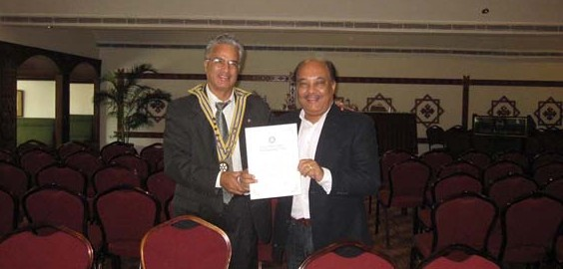
President Som providing a token of appreciation to Guest Speaker Yogendra Shakya.

Friday, 7 October:
Mr Paras SJB Rana, General Manager, Hotel de l’Annapurna, will talk on ‘Green Nepal’. Let us be there to listen him and also share his thoughts on environmental basics, and to see how much green he sees in !

Weekly Meetings and Programs :
Date | Program/Speaker | Program/Topics of Presentation
7 October 2011 | Paras SJB Rana | Green Nepal
14 October 2011 | Dr Buddha Basnet | Travel and mountain medicines
21 October 2011 | Rtn Kul C Gautam | On Rotary regional conference in SriLanka 4 Sep 011
28 October 2011 | Holiday | No meeting

Classification survey results:
Membership Development Committee conducted a classification survey amongst the Club members recently.
The classification survey results were provided in the Club assembly by the the Chair of the committee. Membership profiles and members classifications are provided in this bulletin for benefit of those members who could not attend the club assembly. (Courtsey: Rtn Lisa Choegyal, Chairperson, Membership Development Committee)

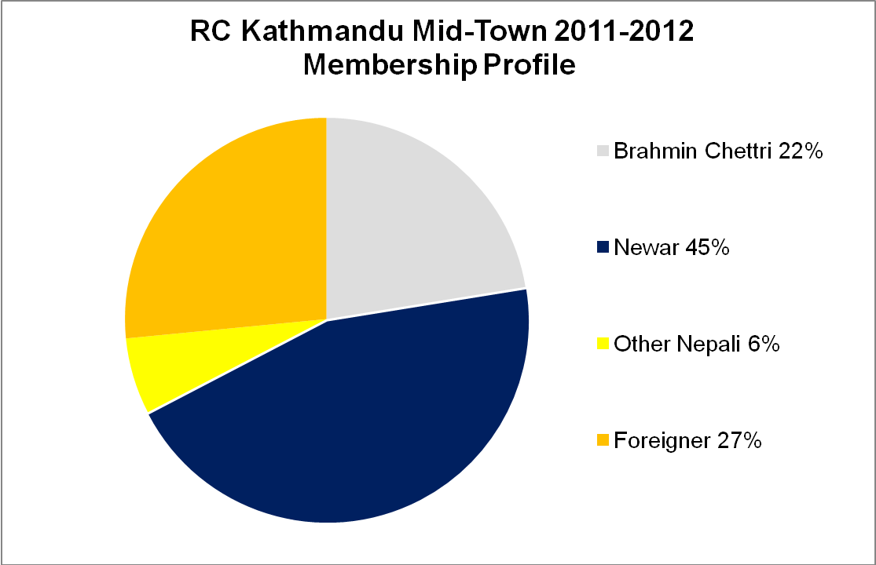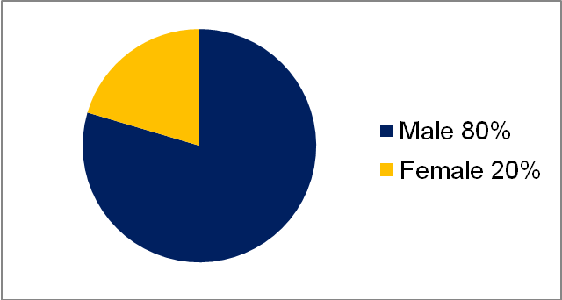
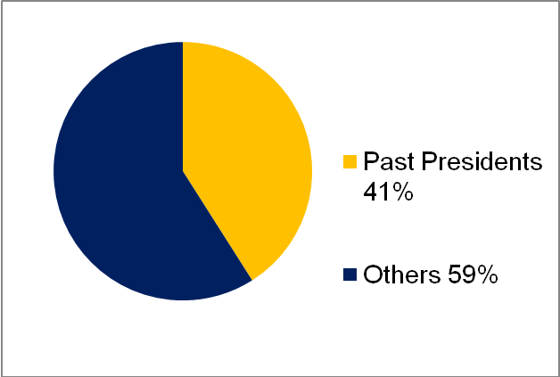
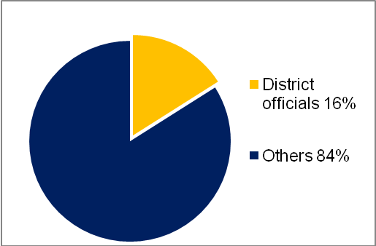
Members’ Classifications
Classifications Nr of members Classifications Nr of members
Accounting 1 Advertising, publicity and PR 1
Ambassador 2 Architecture 1
Artists and art gallery 1 Banking and financial services 1
Business management 2 Child care services 1
Communication services 1 Dentistry 1
Development programme 1 Diplomacy 1
Education – schools/colleges 1 Education - teaching and training 1
Electrical engineer 1 Engineering 1
Environmental services 2 Graphic design 1
Hospitals 1 Hotels 2
Industrialist 1 Import/export 1
Law 1 Management consulting 2
Media 1 Medical doctor 1
Military 2 Neurologist 1
Non-profit organizations 1 Opthomology 1
Paper: trading/manufacture 1 Pharmaceutical and drugs 1
Political scientist 1 Research scientist 1
Restaurants 1 Retired 1
Social entrepreneur 2 Steel industry 1
Tour and trekking operator 2 Tourism consultant 1
Travel and ticketing agency 1 22
27
TOTAL MEMBERS: 49

President-nominee election:
One of the many factors of measuring the effectiveness of the club is timely election of its officers for the incoming years.
Standard Club Constitution provides that a President needs to be elected not less than eighteen (18) months prior to the day of taking office and shall serve as president-nominee upon election.
Kathmandu Mid-Town needs to elect President for the Year 2013-14 by 31 Dec 2011. DGN Dilendra R Shrestha has sent a reminder in this respect recently.
President aspirants, be ready !
RI Convention 2012, Bangkok:


Register now for the 2012 RI Convention in Bangkok, Thailand, 6-9 May, and enjoy an unforgettable experience in the Land of a Thousand Smiles!
First-time convention attendee information:
As a first-time convention attendee, you are embarking on an experience that will inspire you, inform you about Rotary on an international level, and provide you with resources and motivation to move your club forward.
You can learn about strengthening clubs and identifying service and fellowship opportunities by attending an RI Convention and listening to speakers, participating in workshops, visiting the Club and District Projects Exhibition, and talking to fellow Rotarians and other members of the family of Rotary.
During the meeting, you’ll experience the international nature of Rotary. Expect to encounter Rotarians and guests from all over the world, united in the spirit of Rotary and the ideal of service.
Convention checklist:
First step: registration. With your registration, ticket confirmation, and photo ID in hand, you will pick up your convention materials, usually at the convention center. Your registration packet should include name badges, any prepurchased RI event tickets, vouchers, opening plenary session tickets, program books, and transportation guides. The program book and transportation guide are your key convention resources.

Rota-Quiz
The zonal level Rota-quiz is scheduled to be held in November 2011 and final in Jan 2012. The Club needs to form Rota-quiz sub-committee as soon as possible if the Club decides to participate in the District program.

District Conference 2012
The 4th District Conference of RI District 3292 is scheduled to be held on 5-7 January 2012 at Birendra Sabha Griha, Biratnagar.
Register on time to avoid increase in registration fee;
Contact Rtn. Binod Agrawal on 9852021130 for room booking and other details.

I will ask you to search first within yourselves, to understand that all of us, everywhere, have the
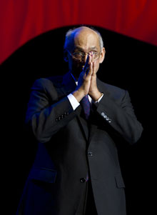
same dreams, the same hopes, the same aspirations, and similar dilemmas. When we understand,
and truly feel, that others’ needs are the same as our own, we begin to understand how important
our work is.
RI President Kalyan Banerjee

Life with computers:



Please send project/activity information, suggestions and photos etc to :
BC Editor: RR Shrestha email: rryes@wlink.com.np

7 October 2011 The Weekly Bulletin of Rotary Club of Kathmandu Mid-Town bc-10.7/011-12

